Counting Objects :

package com.css.corexercise;

//Counting No.Of Objects in class

public class CountObjects {

static int count=0;

CountObjects()

{

count++;

}

public static void main(String args[])

{

CountObjects o1=new CountObjects();

CountObjects o2=new CountObjects();

System.out.println("No.Of Objects :" + count);

}

}

OUTPUT :

No.Of Objects : 2

App4Bank :

package com.css.app4bank.dao;

import com.css.app4bank.dto.BankAccount;

public interface IBankServiceProvider {

public boolean createAccount(String accountName);

public BankAccount checkAccount(String accountNo);

public double getBalance(String accountNo);

public boolean depositMoney(String accountNo,double amount);

public boolean withdrawMoney(String accountNo,double amount);

public boolean transferMoney(String fromAccountNo,String toAccountNo,double amount);

}

BANKACCOUNT : ;

package com.css.app4bank.dto;

public class BankAccount {

private String accountNo;

private String accountName;

private double balance;

private static int lastAssignedNo;

static {

lastAssignedNo=0;

}

public BankAccount(String accountName) {

super();

this.balance=1000;

this.accountNo=Integer.toString(lastAssignedNo+1); //""+lastAssignedNo+1

lastAssignedNo++;

this.accountName = accountName;

}

public BankAccount(String accountNo, String accountName) {

super();

this.accountNo = accountNo;

this.accountName = accountName;

this.balance=1000.00;

}

public String getAccountNo() {

return accountNo;

}

public void setAccountNo(String accountNo) {

this.accountNo = accountNo;

}

public String getAccountName() {

return accountName;

}

public void setAccountName(String accountName) {

this.accountName = accountName;

}

public double getBalance() {

return balance;

}

public void setBalance(double balance) {

this.balance = balance;

}

public BankAccount(String accountNo, String accountName, double balance) {

super();

this.accountNo = accountNo;

this.accountName = accountName;

this.balance = balance;

}

public BankAccount() {

super();

// TODO Auto-generated constructor stub

}

@Override

public String toString() {

return "BankAccount [accountNo=" + accountNo + ", accountName=" + accountName + ", balance=" + balance + "]";

}

}

BANKSERVICEPROVIDER : :

package com.css.app4bank.dto;

import java.util.Set;

import com.css.app4bank.dao.IBankServiceProvider;

public class Bank implements IBankServiceProvider {

private String IFSC;

private String bankName;

//private BankAccount[] accounts;

private Set<BankAccount> accounts;

public Bank(String iFSC, String bankName) {

super();

IFSC = iFSC;

this.bankName = bankName;

}

public String getIFSC() {

return IFSC;

}

public void setIFSC(String iFSC) {

IFSC = iFSC;

}

public String getBankName() {

return bankName;

}

public void setBankName(String bankName) {

this.bankName = bankName;

}

public Set<BankAccount> getAccounts() {

return accounts;

}

public void setAccounts(Set<BankAccount> accounts) {

this.accounts = accounts;

}

public Bank() {

super();

// TODO Auto-generated constructor stub

}

public Bank(String iFSC, String bankName, Set<BankAccount> accounts) {

super();

IFSC = iFSC;

this.bankName = bankName;

this.accounts = accounts;

}

@Override

public String toString() {

return "Bank [IFSC=" + IFSC + ", bankName=" + bankName + ", accounts=" + accounts + "]";

}

@Override

public BankAccount checkAccount(String accountNo) {

BankAccount foundAccount = null;

for (BankAccount account : this.accounts) {

if (account.getAccountNo().equals(accountNo)) {

foundAccount = account;

break;

}

}

return foundAccount;

}

@Override

public double getBalance(String accountNo) {

double balance = 0.0;

BankAccount foundAccount = this.checkAccount(accountNo);

if (foundAccount != null)

balance = foundAccount.getBalance();

return balance;

}

@Override

public boolean depositMoney(String accountNo, double amount) {

boolean depositFlag = false;

BankAccount foundAccount = this.checkAccount(accountNo);

if (foundAccount != null) {

double newBalance = foundAccount.getBalance() + amount;

foundAccount.setBalance(newBalance);

depositFlag = true;

}

return depositFlag;

}

@Override

public boolean withdrawMoney(String accountNo, double amount) {

boolean withdrawFlag = false;

BankAccount foundAccount = this.checkAccount(accountNo);

if (foundAccount != null) {

if (foundAccount.getBalance() >= amount) {

double newBalance = foundAccount.getBalance() - amount;

foundAccount.setBalance(newBalance);

withdrawFlag = true;

}

}

return withdrawFlag;

}

@Override

public boolean transferMoney(String fromAccountNo, String toAccountNo, double amount) {

boolean transferFlag=false;

boolean withdrawFlag=this.withdrawMoney(fromAccountNo, amount);

if(withdrawFlag) {

boolean depositFlag=this.depositMoney(toAccountNo, amount);

if(depositFlag)

transferFlag=true;

else

this.depositMoney(fromAccountNo,amount);

}

return transferFlag;

}

@Override

public boolean createAccount(String accountName) {

boolean createAccountFlag=false;

BankAccount newAccount=new BankAccount(accountName);

this.accounts.add(newAccount);

if(this.accounts.contains(newAccount))

createAccountFlag=true;

return createAccountFlag;

}

}

MAIN ::

package com.css.app4bank.main;

import java.util.HashSet;

import java.util.Set;

import com.css.app4bank.dto.Bank;

import com.css.app4bank.dto.BankAccount;

public class Main {

public static void main(String[] args) {

Set<BankAccount> accounts=new HashSet<BankAccount>();

BankAccount ba1=new BankAccount("Vardhani");

BankAccount ba2=new BankAccount("Thriveni");

BankAccount ba3=new BankAccount("Smce");

accounts.add(ba1);

accounts.add(ba2);

accounts.add(ba3);

Bank axis=new Bank("IND001","Indian Bank");

axis.setAccounts(accounts);

BankAccount foundAccount=axis.checkAccount(Integer.toString(3));

System.out.println("CheckAccount: "+foundAccount.toString());

System.out.println("DepositMoney: "+axis.depositMoney(Integer.toString(3),333));

System.out.println("GetBalance: "+axis.getBalance(Integer.toString(3)));

System.out.println("WithdrawMoney: "+axis.withdrawMoney(Integer.toString(3),300));

System.out.println("Balance After withdraw: "+axis.getBalance(Integer.toString(3)));

System.out.println("TransferMoney: "+axis.transferMoney(Integer.toString(3), Integer.toString(2), 453));

System.out.println("CheckAccount fromAccount: "+axis.checkAccount(Integer.toString(3)).toString());

System.out.println("CheckAccount ToAccount: "+axis.checkAccount(Integer.toString(2)).toString());

System.out.println("Create Account: "+axis.createAccount("Anant"));

System.out.println("Create Account: "+axis.createAccount("Varan"));

System.out.println("Create Account: "+axis.createAccount("Bharath"));

System.out.println("BankAccounts: "+axis.getAccounts().toString());

}

}

OUTPUT :

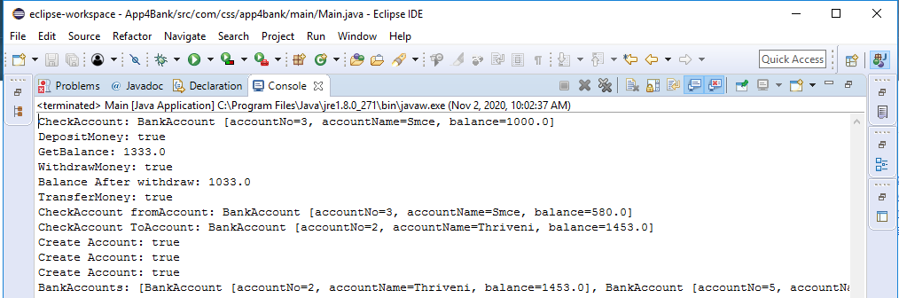

*import java.util.\*;*

public class Employee {

*public static void main (String args[])*

*{*

*HashSet<String> set = new HashSet<String>();* set.add("thriveni");

*set.add("vardhani");* set.add("Syamala");

*set.add("vani");*

*for(into count:empname)*

*{*

*count=0;* if(set.Contains(empname)) count++;

*if(Employee.getempname().equals(this.empname))* return empid;

*}*

*}*

*}*